|  |  |
| --- | --- |
|  | LOST-Wheel Manual |
|  | Version 2 – April 2022 |
|  | JJ Bivona |

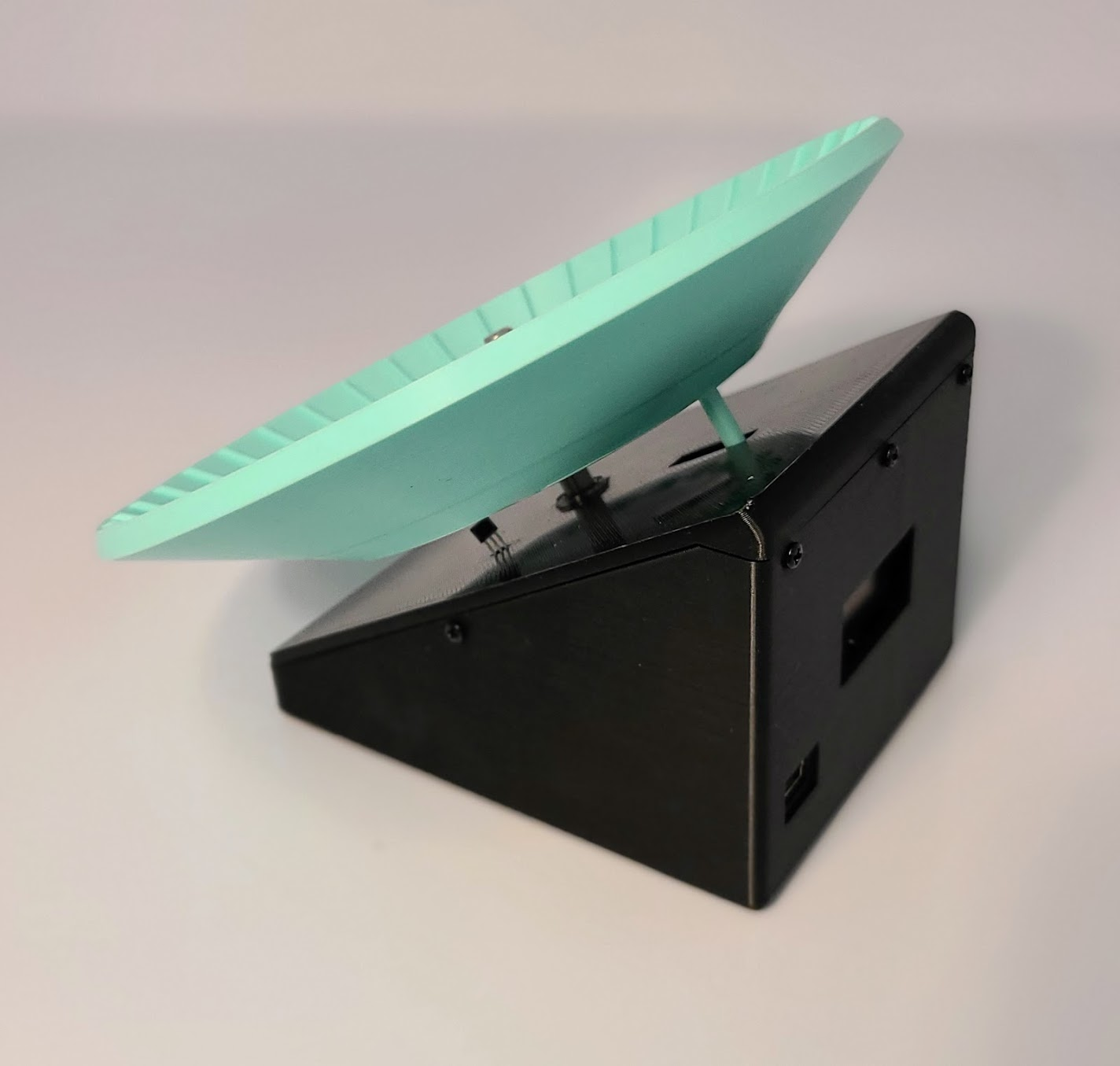

**Welcome**

**­­­** The LOST-Wheel was born out of the necessity to create an inexpensive, data collecting mouse wheel with locking features. Whereas current products can track distances, or be manually locked, they often require cage modifications, human intervention, purchasing additional hardware/software, and are cost prohibitive. Using easily accessible parts, the LOST-Wheel can be assembled for around $25 USD, requires no modifications to a standard shoebox cage, and can be locked without human intervention. We hope that this wheel can assist you in your research and allow some freedom in your budget.

This manual will walk you through the assembly, programming, and operation of the LOST-Wheel. It is designed to make the process as easy as possible. A few notes before you begin:

3D Printing: All parts for the wheel can be printed in standard polylactic acid (PLA) on entry level fusion deposition modeling printers. These types of printers have substantially decreased in price and can be purchased for less than $300 USD. Our lab has an Ender 3 V2 (MSRP $280) that has been a workhorse for our needs. Alternatively, many universities have a 3D printing core or a fabrication lab that can produce the four parts required.

Programming: New to 2022 – the LOST-Wheel Logger application has been turned into a Windows .exe file to streamline programming and data collection. You no longer need to edit Arduino sketches or work with RStudio! As long as you have the correct drivers installed for your Arduino Nano (or Nano clone), the application should take care of the rest. This version of the manual has been changed to reflect the new software. Please refer to Version 1 of the manual for using the Arduino IDE based programming.

Soldering: This part can be tricky, but with some patience and practice any bench scientist can handle this skill. It’s like pipetting, but hotter. **Soldering is not required**, **however it is recommended** for more durable connections to the microcontroller. To use pin-style connections to the Arduino Nano, see section 3.5.3 and be sure to download and 3D print the “no solder version” of the LOST-Wheel Bottom.

Assembly: There are only a handful of screws that hold the LOST-Wheel together, and many pieces are press-fit into place.

All required files may be downloaded from [www.github.com/jjbivona/LOSTwheel](http://www.github.com/jjbivona/LOSTwheel)

This project is designed to be open source and free for research use. It is licensed under a Creative Commons Attribution-NonCommercial-ShareAlike 4.0 International License. We ask that if you use this in your research to please cite our original paper found here [link after publication].

**Table of Contents**

Contents

1. Materials 1

2. 3D Printing 2

2.1 Basics of 3D Printing 2

2.2 Our Print Settings 2

2.3 Helpful Tips 2

3. Assembly Instructions 3

3.1 Uploading the setup sketch 3

3.2 Wiring 4

3.3 Testing components 7

3.4. Device assembly 8

4. Programs and modes 15

4.1 Distance Mode 15

4.2 Timer Mode 15

4.3 Duration Mode 15

4.4 Unlimited running 15

4.5 Starting the LOST-Wheel Logger application 16

4.6 Uploading to the LOST-Wheel 16

4.7 Recording data from the LOST-Wheel 17

Appendix I 18

# 1. Materials

|  |  |  |
| --- | --- | --- |
| * 1. LOST-Wheel Component List | | |
| **Component** | **Quantity** | **Link:** |
| 6 mm ID, 10 mm OD, x 3 mm bearing | 3 | [6 mm Bearing](https://www.amazon.com/uxcell-MR106-2RS-Groove-Bearings-Double/dp/B082PSCNKB/ref=sxts_b2b_sx_reorder_v3_customer?cv_ct_cx=6mm+bearing&dchild=1&keywords=6mm+bearing&pd_rd_i=B082PSCNKB&pd_rd_r=a8dee85e-8349-456c-9ef9-efe6bbc74a69&pd_rd_w=HT1PN&pd_rd_wg=e6PKH&pf_rd_p=957bd7e3-74ac-4a2b-82e1-84ce13da595b&pf_rd_r=7D56A73YZYD9C224TXZG&qid=1633958694&sr=1-1-722db4e4-77fc-4fb6-8cee-654ad16ce1d5) |
| 6 mm D axel cut to 65 mm | 1 | [250 mm Axl](https://www.amazon.com/ReliaBot-11-811-inches-Hardened-Chrome/dp/B07QZ3CL4D/ref=pd_d_sim_b2b_3/132-8230010-9811234?pd_rd_w=Pe6rs&pf_rd_p=6363e0f9-52c6-435d-8167-278537f95c20&pf_rd_r=4A065Z8T8FTF3QQ7NM2N&pd_rd_r=5514d019-e70a-47f9-9ab7-367ef31d8238&pd_rd_wg=fq5O2&pd_rd_i=B07QXZMC5M&th=1)e |
| M3x5 self-tapping screw | 1 | [M2, M2.3, M3 Screw Set](https://www.amazon.com/Phillips-Laptop-Computer-Self-Tapping-Electronic/dp/B07S337WBB/ref=sr_1_3?dchild=1&keywords=m2+m2.3+m3+self+tapping&qid=1633958230&sr=8-3) |
| M2.3x8 self-tapping screw | 8 |
| M2x6 self-tapping screw | 1 |
| M1.7x6 self-tapping screw | 8 | [M1 Screw Set](https://www.amazon.com/Phillips-Micro-Screws-Self-Tapping-Electronic/dp/B07GKXMSVR/ref=sr_1_8?dchild=1&keywords=m1.7x6&qid=1633957982&sr=8-8) |
| 10 mm x 5 mm x 3 mm neodymium magnet (or similar) | 2 | [10x5x3 mm Magnet](https://www.amazon.com/gp/product/B07KP2XLYY/ref=ppx_yo_dt_b_search_asin_image?ie=UTF8&psc=1) |
| 22-gauge, 2.54 mm breadboard jumper wires, 3 male, 7 female | 10 | [Elegoo Jumper Wires](https://www.amazon.com/gp/product/B01EV70C78/ref=ppx_yo_dt_b_search_asin_title?ie=UTF8&psc=1) |
| Arduino Nano (or similar) | 1 | [Elegoo Nano Clone](https://www.amazon.com/gp/product/B0713XK923/ref=ppx_yo_dt_b_search_asin_title?ie=UTF8&psc=1) or [Arduino Nano](https://www.amazon.com/Arduino-Nano-Every-Boards-Pack/dp/B07YQ56B6Q/ref=sr_1_6?dchild=1&keywords=arduino%2Bnano&qid=1633954240&s=electronics&sr=1-6&th=1) |
| 9g micro servo | 1 | [Plastic Gear](https://www.amazon.com/gp/product/B072V529YD/ref=ppx_yo_dt_b_search_asin_title?ie=UTF8&psc=1) or [Metal Gear](https://www.amazon.com/gp/product/B07S85BC41/ref=ppx_yo_dt_b_asin_title_o00_s01?ie=UTF8&psc=1) |
| KY-003 hall effect sensor | 1 | [Hall Effect Sensor](https://www.amazon.com/gp/product/B07JMQFY6G/ref=ppx_yo_dt_b_search_asin_title?ie=UTF8&psc=1) |
| 0.96 inch 128x64 OLED Screen  I2C connection SSD1306 Driver | 1 | [OLED Screen](https://www.amazon.com/GeeekPi-SSD1306-Display-Arduino-Raspberry/dp/B0833PF7ML/ref=sr_1_4?crid=3BSGNLNYDBGXZ&dchild=1&keywords=0.96+inch+oled+module&qid=1633954782&s=electronics&sprefix=0.96%2Celectronics%2C159&sr=1-4) |

# 2. 3D Printing

## 2.1 Basics of 3D Printing

Each printer and filament will require different tuning strategies and setup. For the beginner’s guide, I recommend [this article by All3DP](https://all3dp.com/2/3d-printing-for-beginners-all-you-need-to-know-to-get-started/). All3DP has many troubleshooting and setup articles to help even the most novice builders get high quality prints.

## 2.2 Our Print Settings

* Printer: Ender 3 V2
  + Upgrades: BL Touch (not required for LOST-Wheel), direct drive (not required for LOST-Wheel).
* Slicing Software: Ultimaker Cura 4.9
* Filament: Hatchbox PLA 1.75 mm
* Print Settings:
  + Quality: 0.2 mm layer height
  + Build Plate Temp: 60°C
  + Hot End temp: 200°C
  + Build Plate Adhesion: Brim
  + Supports: ON for “Bottom”, OFF for “Wheel,” “Top,” and “Servo Pin”

## 2.3 Helpful Tips

* Level the print bed often, or install an automatic bed level device to do it for each print
* Clean the print bed thoroughly before each print with isopropanol
* Do not put the printer next to another device that emits hot air or vibrates

# 3. Assembly Instructions

## 3.1 Uploading the setup sketch

**3.1.1 Connect microcontroller to computer through USB**

**IMPORTANT: When uploading any sketch through the LOST-Wheel Logger Application only ONE Arduino can be connected at a time.**

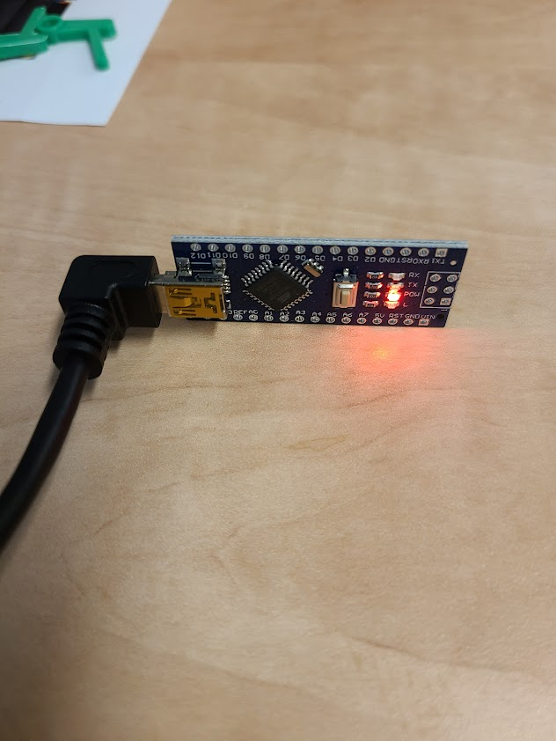

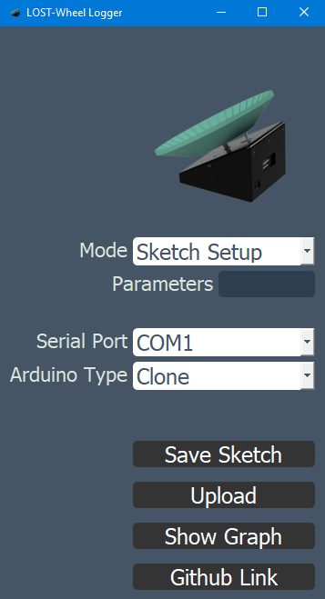

**3.1.2 Open LOST-Wheel Logger Application**

**3.1.3 Select “Sketch Setup”**

**3.1.4 Ignore “Serial Port”**

**This is only used for graphing purposes**

**3.1.5 Select “Clone” if your board is not directly from Arduino**

**3.1.6 Click “Upload”**

**The initial upload will take slightly longer as it needs to install required libraries.**

## 3.2 Wiring

**Notes:**

* Soldering is not necessary to create the LOST-Wheel, but is recommended. Alternatively, pin-style connections can be used with the Arduino Nano. **Should this route be taken make sure to** **download and 3D print the correct model labeled “no solder version.”** The location of the USB connector has been changed to account for the pins. See Appendix I for additional details.
* Please refer to the wiring diagram on **page 6** for this section of the manual.
* Unplug Nano before soldering.
* Take necessary safety precautions while soldering.
  + 1. **Cut and strip 3 male jumper wires and 7 female jumper wires**

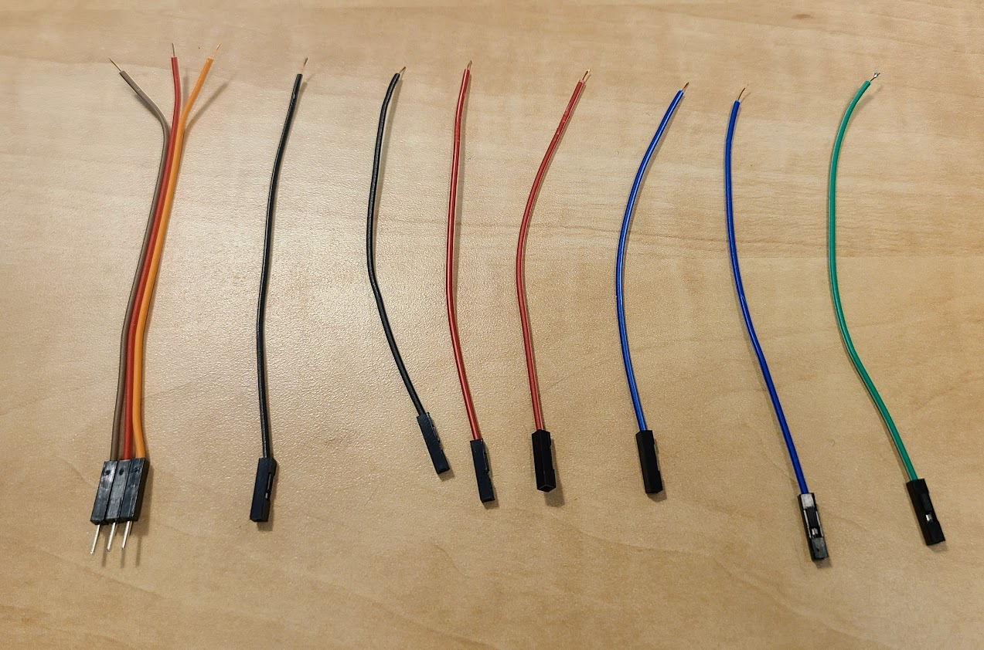

* + 1. **Apply solder to exposed ends of wires**
    2. **For the ground wires, twist two wires together and apply solder to the twist**

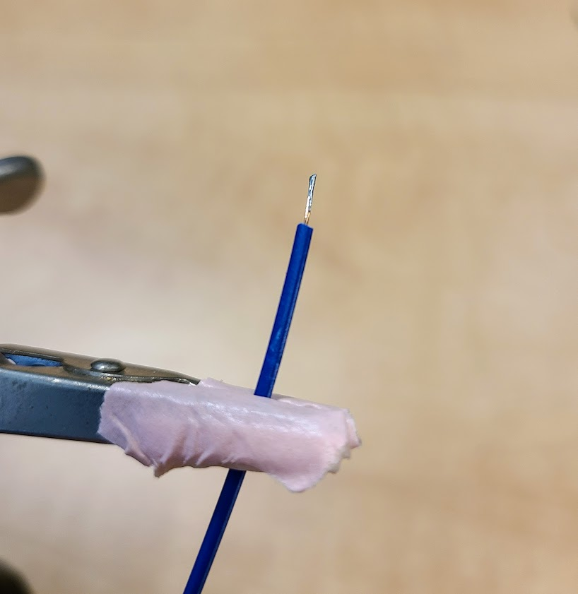 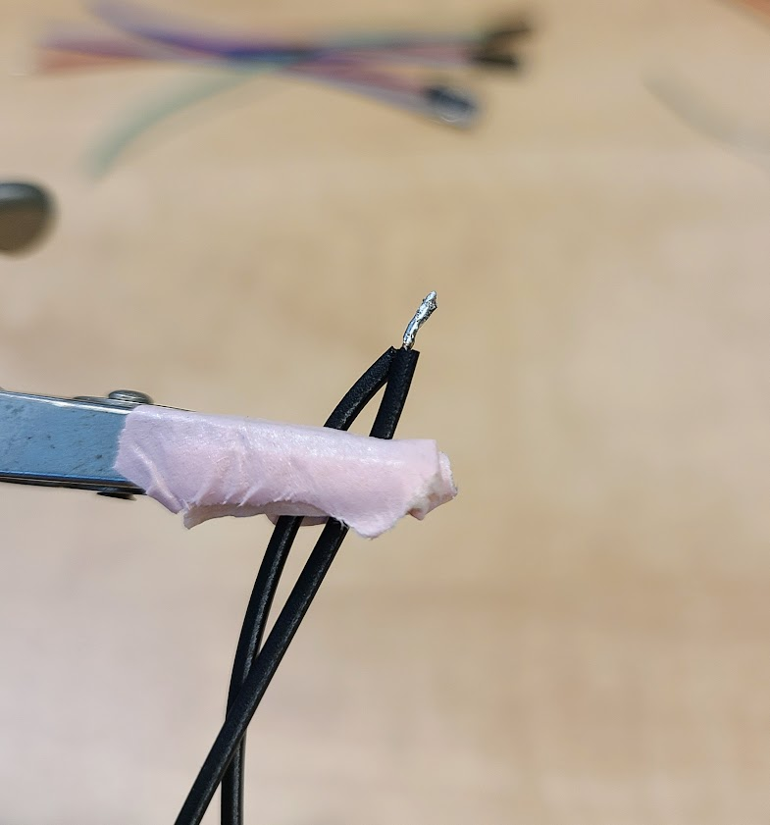

* + 1. **Apply solder to appropriate pins of the Nano**

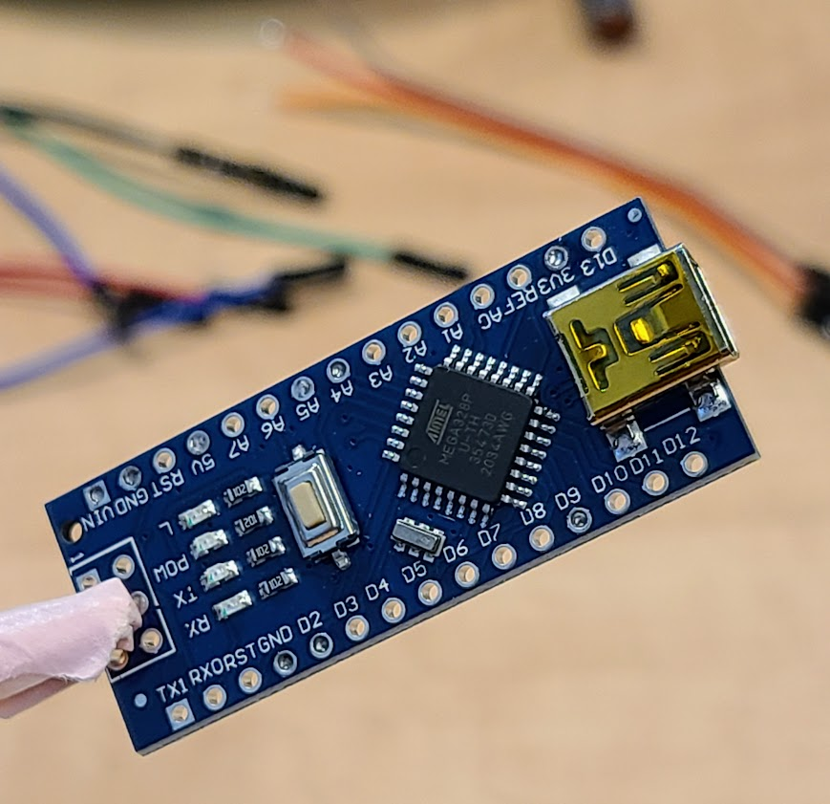

* + 1. 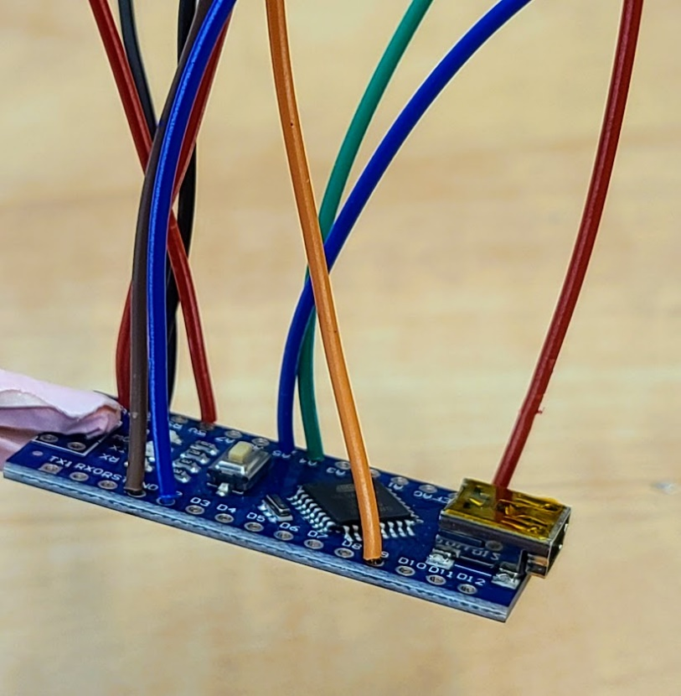**Fuse wires to the pins of the Nano**

LOST Wheel Wiring Diagram

## 3.3 Testing components

**3.3.1 Refer to the wiring diagram to attach the servo, screen, and Hall effect sensor to the correct wires**

* + 1. 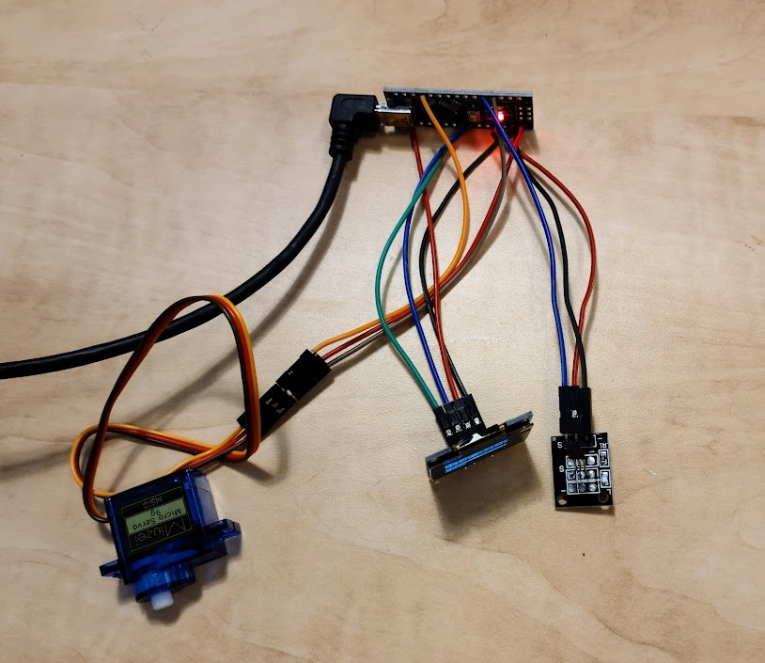**Plug Nano into USB power source**
    2. **Confirm screen turns on and wave a magnet in front of Hall effect sensor to test**
  1. **A red LED should flash, and the counter should increase by 1**

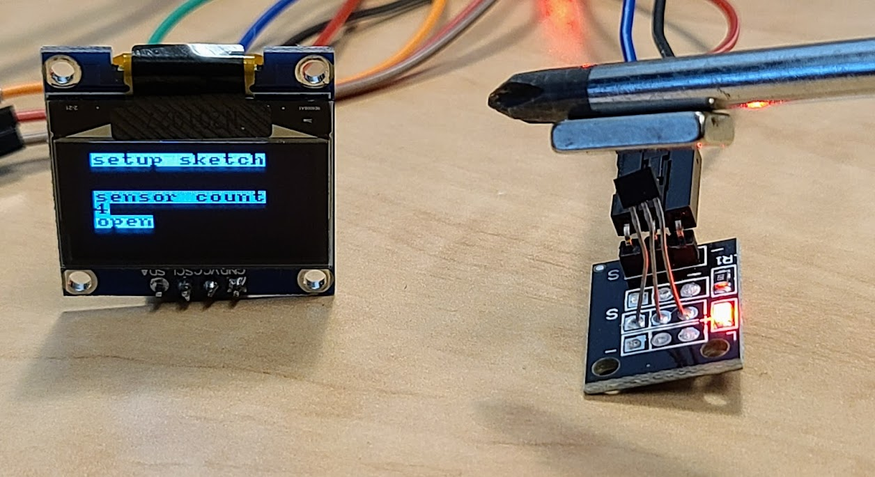

* + 1. **Confirm servo movement**
    2. **The servo will move 20° every 10 seconds**

**If any component is defective, replace and retest before proceeding.**

## 3.4. Device assembly

* + 1. **Press magnets into wheel**
  1. **Tip: wedge one side of the magnet into the slot, flip the wheel over and press down on a hard surface. The magnet should snap into place. Repeat for second magnet.**

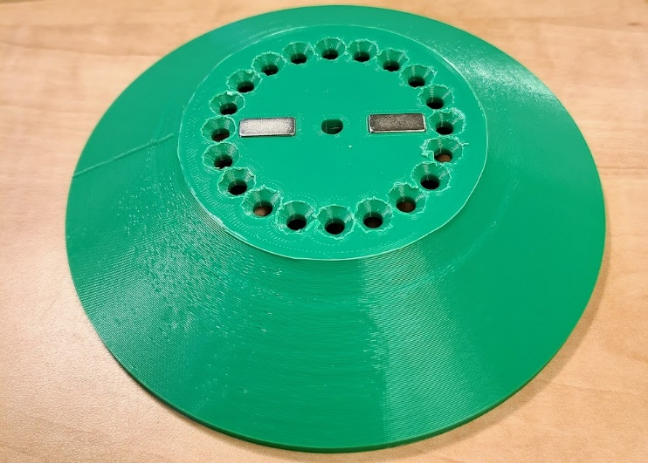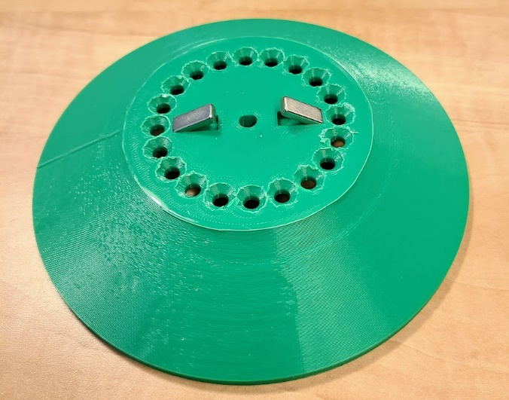

* + 1. **Press bearings into both sides of top and into the base**

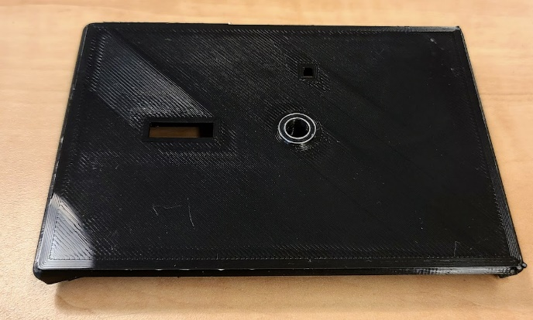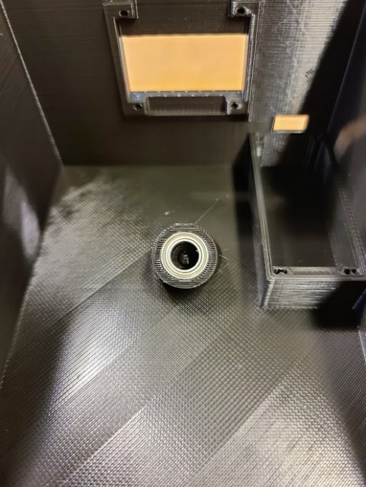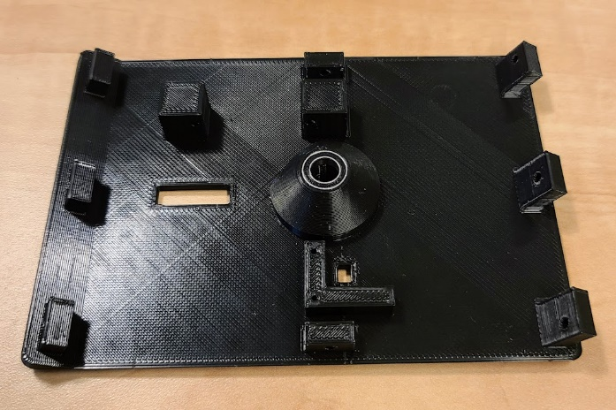

* + 1. **Attach servo using 1 M1.7x6 screw**

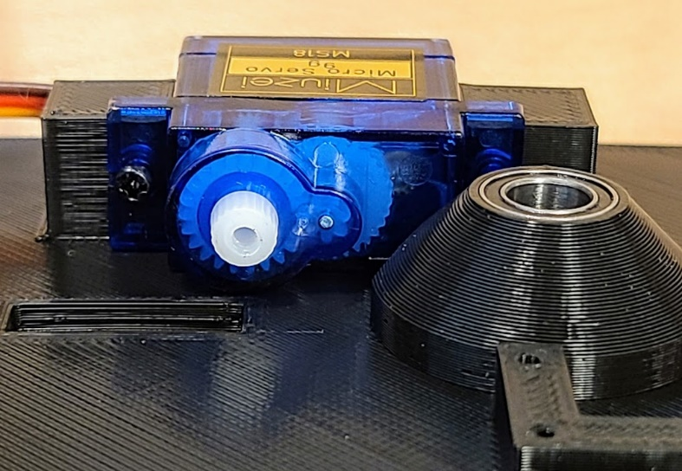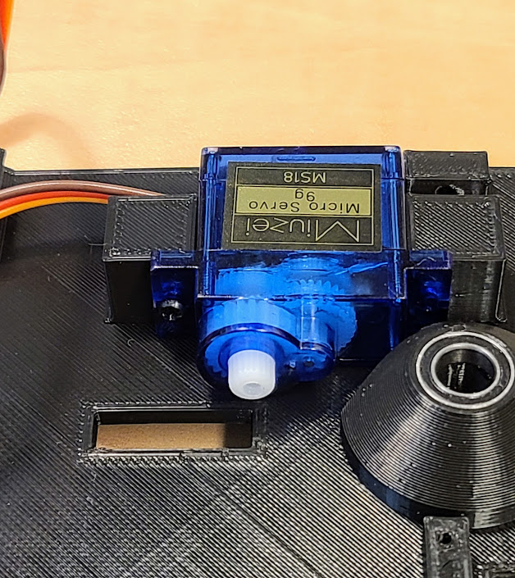

* + 1. 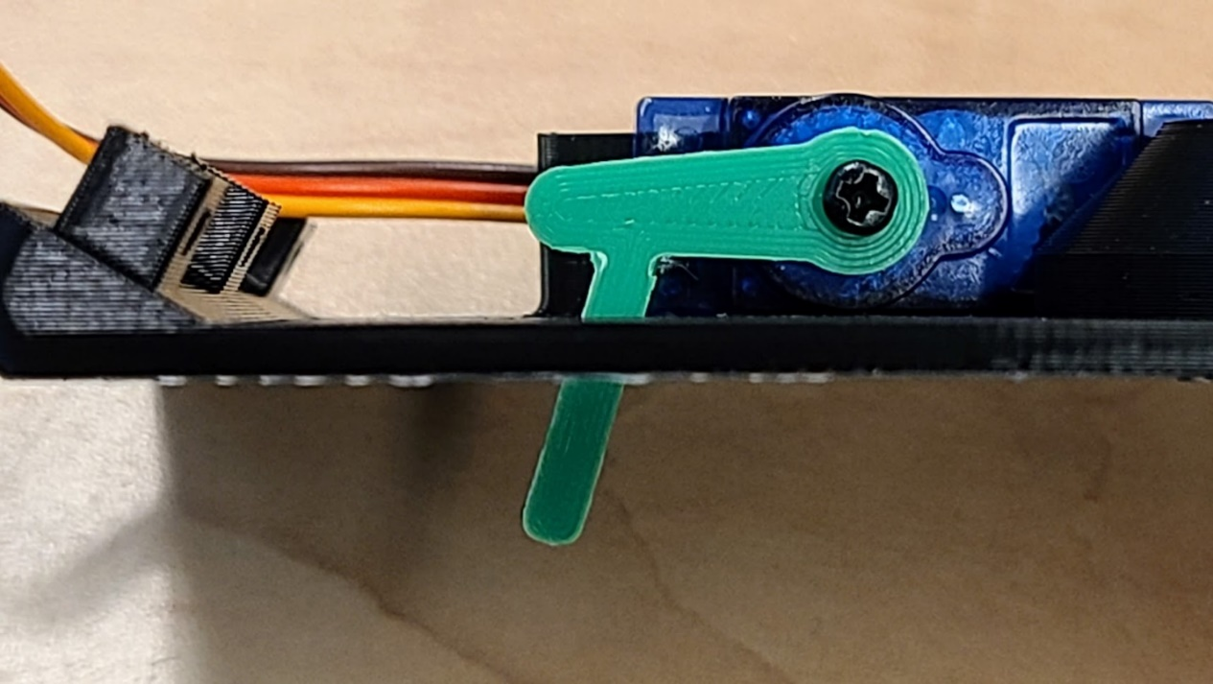**Power on the LOST-Wheel and while the servo is in the OPEN position as indicated by the OLED screen, press the locking pin onto the servo so that it is parallel to the top plate. Secure locking pin to servo using 1 M2x6 screw.**
    2. **Attach hall effect sensor using 2 M1.7x6 screws**

**Thread the sensor head (blue arrow) through the LOST-Wheel top before fastening screws.**

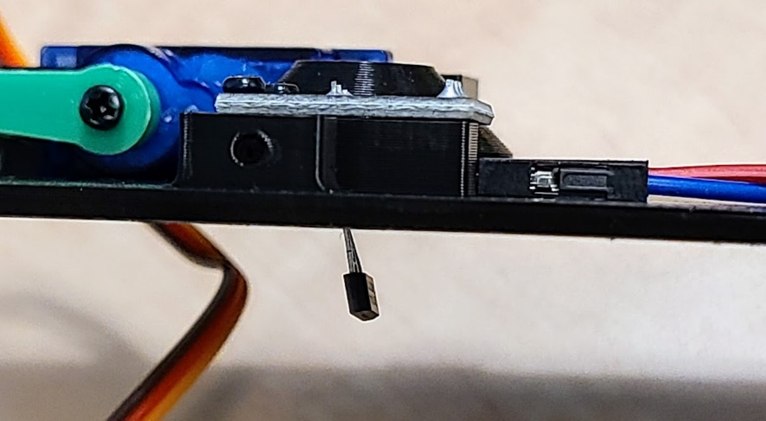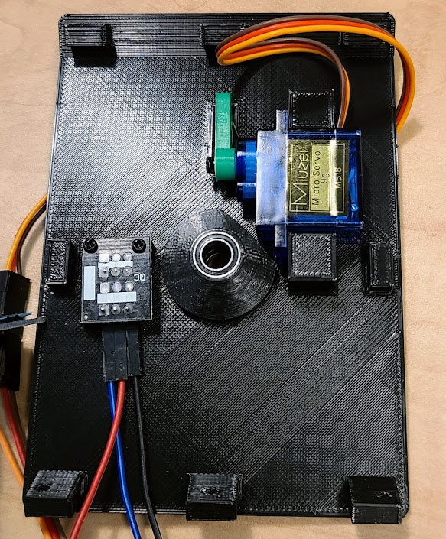

* + 1. **Attach screen using 4 M1.7x6 screws**

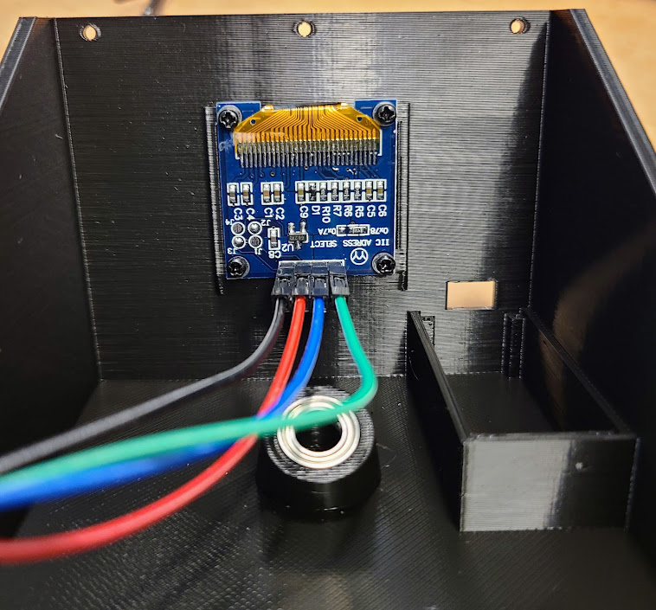

* + 1. **Attach Nano using 1 M1.7x6 screw**

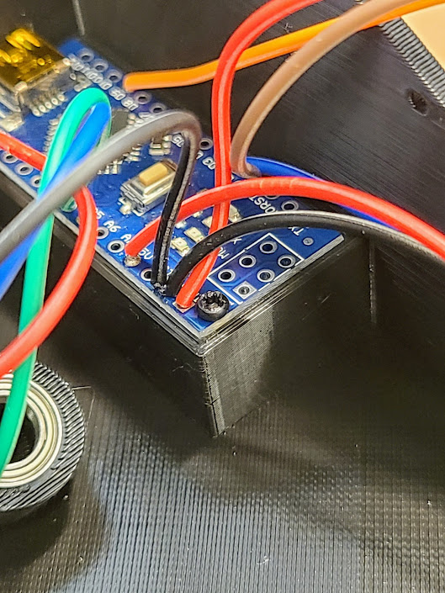

* + 1. **Position screen wires away from axle mounting point.**

**Optional: Secure wires with tape**

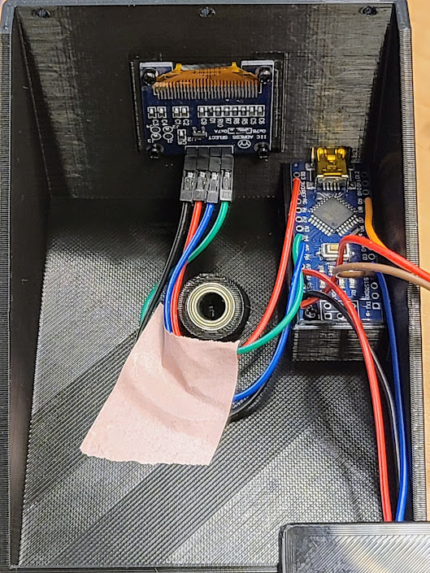

* + 1. **Secure the top and base pieces using 8 M2.3x8 screws**

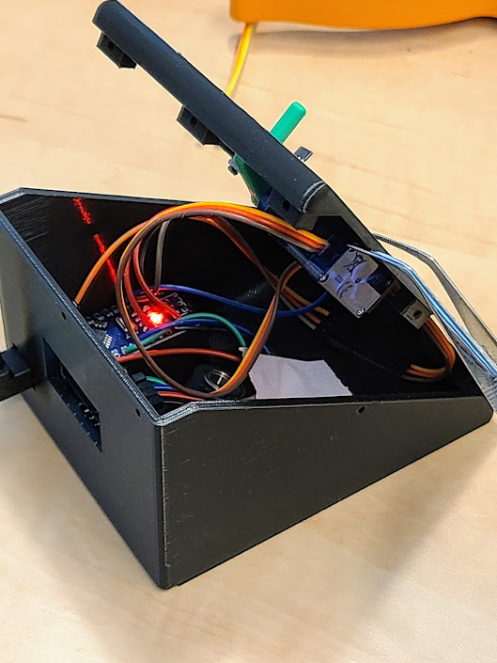 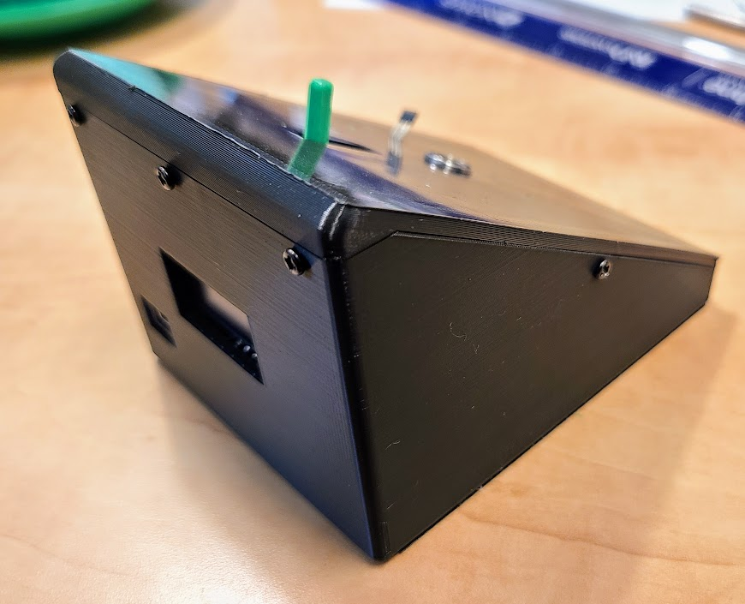

* + 1. **Attach wheel to axle**

**Mark drive shaft 49mm from one end**

**Slide wheel onto axle until mark is covered**

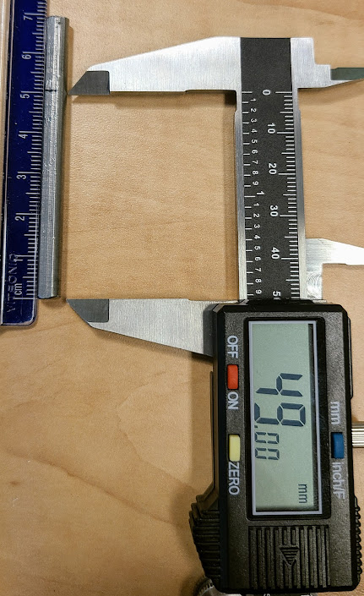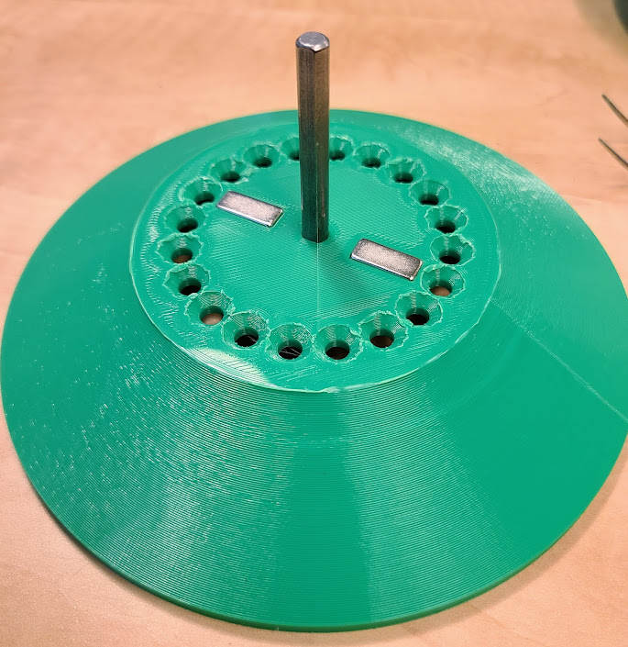

* + 1. **Insert axle into the base**
    2. **Confirm locking mechanism operation by powering wheel and using the setup sketch**

**Subtle adjustments of the wheel/shaft may be required for proper locking**

**When in the open position, there should be 2-3 mm of clearance between wheel and pin**

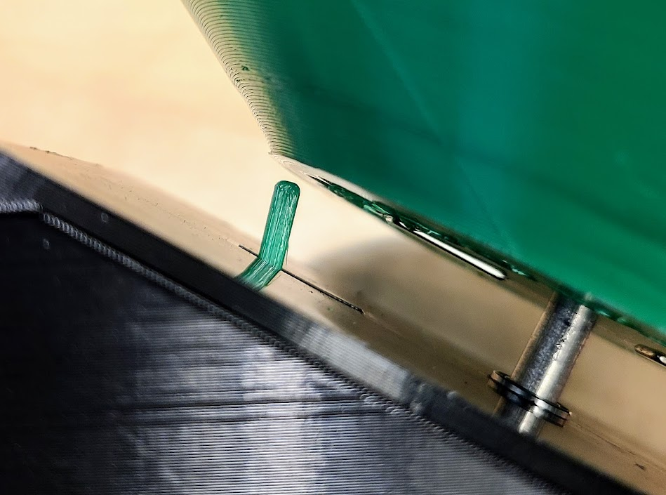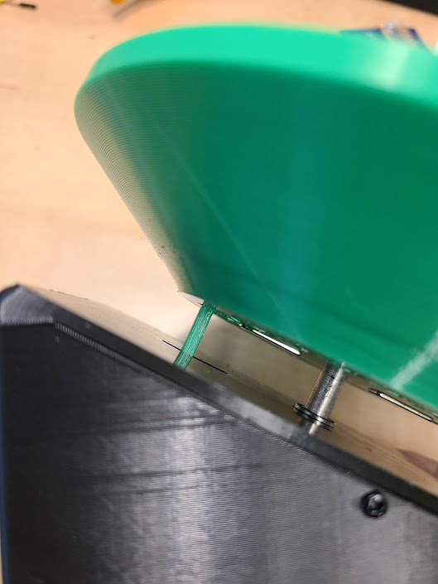

LOCKED

OPEN

* + 1. **Secure wheel to axle with a M3x4 screw**

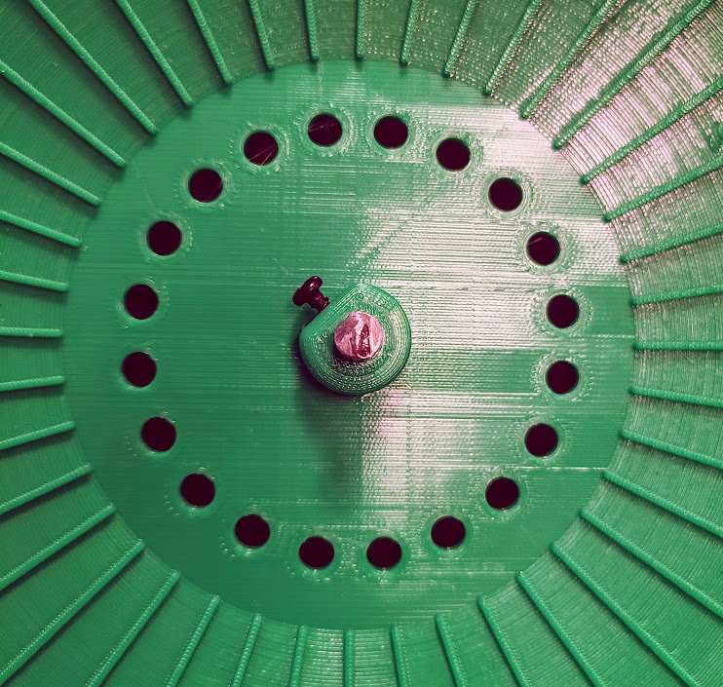

# 4. Programs and modes

The LOST Wheel can be programmed for distance-based locking (Distance Mode), duration-based locking (Duration Mode) or for timed intervals of running and rest (Timer Mode). Both modes can be used for a standalone wheel (no computer required) or in combination with the LOST-Wheel Logger application to obtain more detailed data about speed and time duration.

**Distance Mode** –the wheel begins unlocked and will lock upon reaching a set milestone.

**Timer Mode (two and four states)** –the wheel can be set to unlock or lock at certain intervals that are based on when the device is powered on.

**Duration Mode –** the wheel locks after the mouse exercises for the determined amount of time.

**Setup Sketch –** to use when assembling the wheel

**Blink –** this is a basic Arduino sketch to make sure the Nano can receive data from the computer. A small LED blinks on and off on the board.

## 4.1 Distance Mode

This mode will lock the wheel once the distance milestone is reached. To reset, disconnect and reconnect from a power source.

## 4.2 Timer Mode

This mode allows users to specify times at which the wheel will be locked and unlocked. It is important to note that the Arduino Nano does not have a real time clock built in. This means it cannot tell time in the conventional sense. The timer used in this mode is based on when the device is powered on. Therefore, some coordination is required between programming and turning the device on. For example, if you would like the wheel to unlock at 7 PM, and plan on turning the wheel when you leave the lab at 5 PM, set Locked Period 1 to 2 hours.

## 4.3 Duration Mode

This mode keeps track of the amount of time the wheel has been spinning >0.2 m/s and locks when a duration milestone is reached. To reset disconnect and reconnect to the power source.

## 4.4 Unlimited running

There is no true unlimited running mode, but this can be achieved in three ways:

Distance Mode: set distance to an unattainable distance for the mice to achieve within the experiment.

Timer Mode: set Locked Period 1 = 0. Set Unlocked Period 1 to the duration of your experiment

Duration Mode: set Time Threshold to an unattainable time for the mice to achieve within the experiment.

## 4.5 Starting the LOST-Wheel Logger application

4.5.1 The LOST-Wheel Logger can be downloaded from github.com/jjbivona/LOSTWheel and installed by clicking the executable file. Following the installation wizard will install the Logger, Arduino IDE, and all necessary packages required for programming and recording data from the device.

4.5.2 Make sure you have installed the USB drivers for your nano.

4.5.3 The first time using the application will take slightly longer as the program needs to download and install several Arduino Libraries. This will only happen on the first use.

## 4.6 Uploading to the LOST-Wheel

**IMPORTANT:** when uploading sketches to the LOST-Wheel, only one wheel can be connected at a time. If multiple devices are connected, the application cannot upload a sketch. Multiple wheels can then be reconnected for data acquisition.

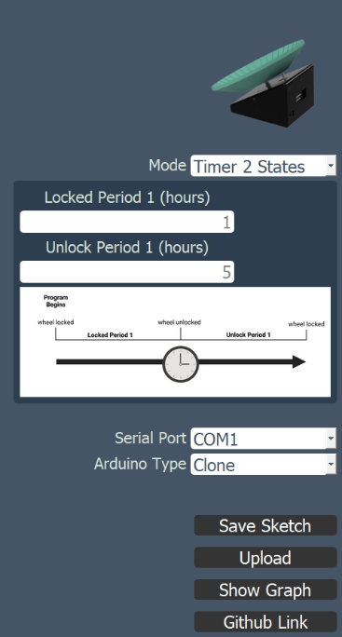

4.6.1 Select the mode you wish to use

4.6.2 Fill out the parameters required for your experiment

4.6.3 If using an Arduino clone select Clone

4.6.4 Click **Save Sketch**

4.6.5 Click Upload to send to your device

4.6.6 Repeat as needed for additional wheels

## 4.7 Recording data from the LOST-Wheel

4.7.1 Connect your device(s) through USB ports or a USB hub.

4.7.2 Identify the COM ports for each wheel by opening your computer’s device manager

Navigate to “Ports (COM & LPT)” and expand the options to view active ports

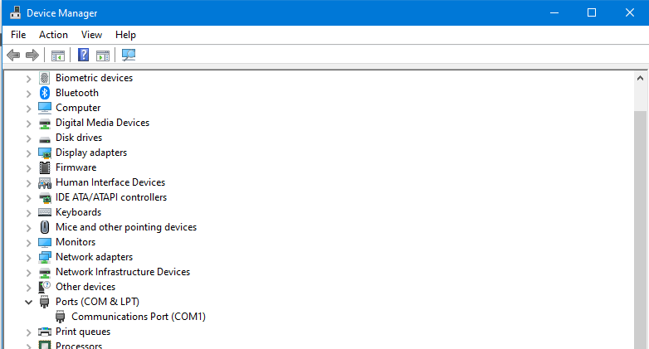

4.7.3 Hit “Show Graph” to begin collecting data.

Note: this will reset the wheel, so take this into consideration if using the timer modes.

4.7.4 Switch COM ports for additional wheels and click “Show Graph” for each

4.7.5 Record data for the duration of your experiment

4.6.6 After data collection period is over, click “Stop” and you will be prompted to save data

# Appendix I

## Using pin-style connections to the Arduino Nano

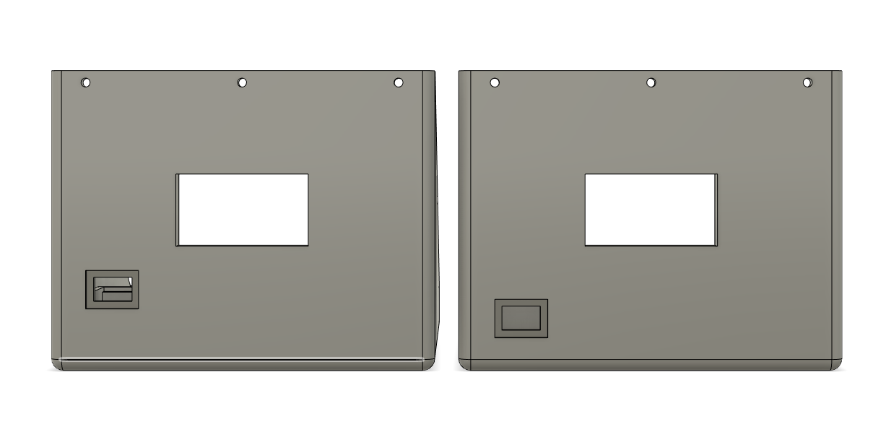**It is pivital to download and print the correct bottom section. If using the pin-style connections, please use the file labeled “LOST-Wheel Bottom – no solder version.”**

No solder

Solder

**The USB port has been moved to account for the microcontroller pins**

**Two ground wires will need to be connected together: visit this link for a tutorial**

[**https://mschoeffler.com/2017/12/26/diy-y-adapter-jumper-wire/**](https://mschoeffler.com/2017/12/26/diy-y-adapter-jumper-wire/)

**Connect all wires to the Nano (pin style)**

